**Any iFor NPJ schizophrenia**

**Introduction**

Recently, researchers in schizophrenia have noted that “time-varying environmental risks associated with mental health outcomes are amenable to within-person designs" and that within person methods may offer additional insights [1]. Both those suffering from and treating schizophrenia are well aware the illness is not static, with one challenge in the clinical management being to distinguishing between the more enduring vs dynamic aspects of the illness. Knowing which aspects of schizophrenia are appropriate for short vs long term for recovery targets and which are most amenable to certain therapies requires a nuanced understanding of symptoms. While impressive new research is beginning to investigate symptoms fluctuation, less remains known at a personal level. For example, longitudinal research characterizing schizophrenia with the PANSS at five time points across 23 months suggests more dynamic symptoms are: grandiosity, preoccupation, somatic concerns, guilt feeling, and hallucinatory behavior while more enduring are poor attention, delusions, blunted affect, poor rapport, and mannerisms [2]. Yet understanding how symptoms fluctuate on a personal level and more clinically relevant timeframe of days and weeks, instead of months and years, remains elusive.

Recently, the advent of smartphone assessments offers a solution with the ability to easily assess symptoms in a naturalistic and longitudinal manner. However, simply offering surveys directly via the smartphone misses the full potential of this method. For example, one potential bias in smartphone surveys in schizophrenia is that adherence may be associated with higher levels of psychosocial functioning [X]. Thus, efforts to stratify symptom reporting by using geolocation to identify home vs other locations may help reduce bias through adding relevant context. Prior research, even during COVID-19, has utilized smartphones to estimate home time and other estimates of times spent in location for patients with schizophrenia [Y]. Research using smartphone surveys has reported how this location data, especially being at home, can influence self-reported metrics related to social cognition and functioning [Y1]. For example, one team also reported that when patients self-report they are at home and alone, there was an association with more severe delusions, although not hallucinations [Y2]. Another team used smartphone passive data and surveys to determine a correlation between more severe auditory and visual hallucinations and time spent at home [Y3] although did not examine the association between being at home and occurrence of these symptoms. Thus, research extending these findings through using objective metrics of home time derived from smartphone geolocation data is a logical next step in this work.

This report, analyzes *active* data that consists of symptoms scores collected via self-reported ecological momentary assessment (EMA) surveys and *passive* background data collected via sensors located on the smartphone devices for patients with a diagnosis of schizophrenia. The self-reported symptom scores on EMA surveys within an app were highly correlated with scores on gold standard clinical assessments administered during visits, thus indicating the reliability of these EMA self-reports. This report also investigated whether the correlation in the various symptoms were driven by inter- or intra-individual differences in individuals. The analysis showed that the inter-individual differences account for a much larger proportion of the correlations in symptoms than intra-individual differences. Lastly, the effect of geo-location (home vs not at home) on average self-reported symptoms was determined and it was observed that some symptoms are worse when surveys are taken at home, compared to not at home. Correlations were 1) driven by inter vs intra individual differences around self-reported outcome and 2) the influence of environmental factors, specifically home time, around self-reported symptoms

**Methods:**

Data collection platforms

In this study, two types of data were collected using smartphones – user-reported or active data and sensor-reported or passive data. ﻿Active data is self-reported responses to the ecological momentary assessment (EMA) survey questions shown in Table 1. Scores of moods, anxiety, sleep, psychosis, social positive and social negative symptoms were calculated by adding or averaging the responses to all questions of a certain type. Passive data consists of background data collected using sensors (e.g., GPS, accelerometer, screen time, call and text logs) on the smartphone with no user involvement. A research application called mindLAMP was installed on participants’ smartphones as part of an Institutional Review Board-approved study (2017P-000359), wherein the surveys were given, and passive data was reported.

Participants and data collection protocol

A total of 86 patients (>=18 years old) with a diagnosis of schizophrenia (SZ) or schizoaffective disorder were recruited from the Greater Boston Area from date August 2019 to date May 2021 (demographics in Table 2). Active and passive data was collected via the mindLAMP application over this period and through 5 clinical visits, either online or in-person. The clinical visits were spread out uniformly over the data collection period.

During the data collection period, participants were prompted on their smartphone to take daily surveys consisting of the questions in Table 1. Simultaneously, passive data was collected through multiple sensors located on the smartphone – GPS data, accelerometer data, screen on/off and call and text logs. At the clinical visits, participants responded to full-length clinical assessments in the presence of a clinician.

Data quality analysis (outlier rejection)

Active data was analyzed for participants who took at least 1 survey (63 out of 86). Of the 86 participants, the median number of surveys taken was 21 (max: 137). Passive data was analyzed for each day which had non-zero data samples. Fraction of home-time for each day was calculated for each participant whenever there were >1000 samples for the day. This threshold was calculated based on the minimum number of samples expected from an acceptable sampling frequency.

Active vs passive data analysis

Active data was analyzed by calculating total, mean, and variance of reported scores. Passive data from GPS sensors was used to determine geo-location with respect to home. Home location was calculated as the mode of latitude and longitude location when binned into blocks of about 8 meters (by rounding to the nearest 0.0001). Home-time was calculated as the amount of time each day that was spent within 150 meters of the home location, and the fraction of home-time is the fraction of the time spent within 150 meters of home-location in a 24-hr period.

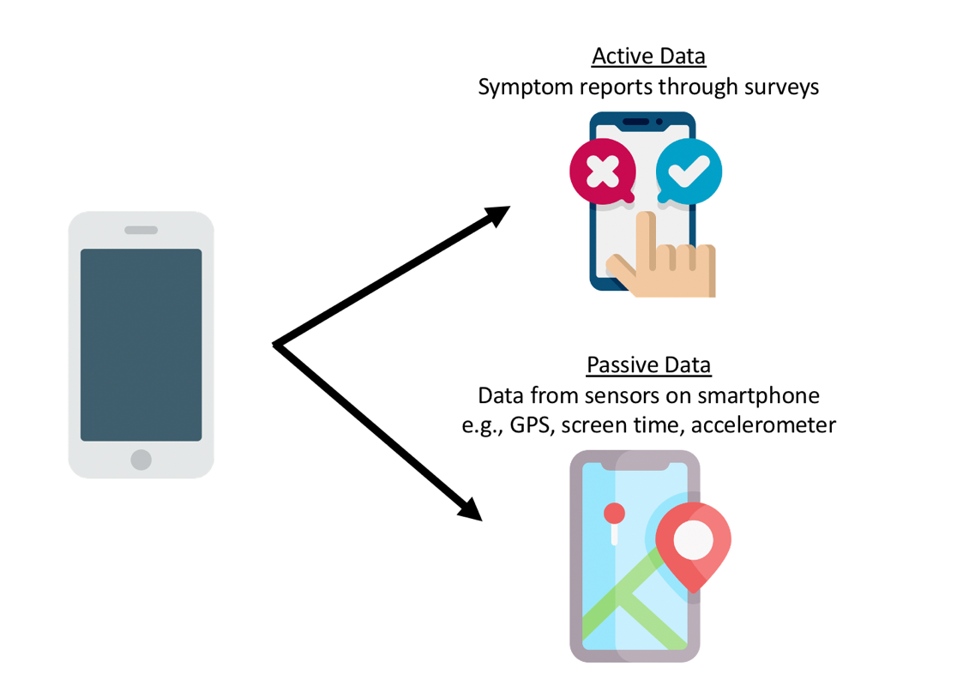

**Figure 1: Description of data from mindLAMP:** Active data is collected through daily surveys given on the app. Passive or background data is collected from sensors on the phone

**Results:**

Clinical vs Self-Reported App Assessments

In order to assess the reliability of the self-reported symptom scores, a simple correlation analysis was performed between the EMA symptom scores (mood and anxiety) and the full-length clinically administered assessment scores to each patient. Figure 2 shows a high correlation (r = 0.80, p = 10-11 for mood and r = 0.78, p = 10-12 for anxiety) between the average clinically administered score and the average self-reported score for all patients. Interestingly, however, we observe that mood and anxiety symptoms are, on average, lower in EMA self-reports (p = 10-6 for mood, and p=10-2 for anxiety), thus suggesting that patients tend to under-report symptoms within the app as compared to in the presence of clinicians.



**Figure 2: Congruence between self-reports and clinical visit reports:** Self-reported symptoms are highly correlated but lower on average than the scores administered during clinical visits

Correlation across symptoms

In order to measure how reports of different symptoms are related to each other, the survey reports across all patients and all surveys taken (N=2462) were combined. A simple correlation analysis shows that the symptom scores are highly correlated with each other, as illustrated by the correlogram (Fig 3a). These correlations between the different symptom scores arise due to a combination of inter-subject correlation as well as intra-subject correlation, e.g., a patient might report some symptoms to be higher than average which would drive correlation between symptoms (intra-subject correlation) or a participants may display symptom trends on a population level (inter-subject correlation). A breakdown of these correlations shows that the correlation across these symptoms is largely due to intra-subject correlation and not due to inter-subject correlation, e.g., participants with high average score of mood symptoms have a higher average score of anxiety and vice versa (Fig 3b-c)

**Figure 3: Relationship between symptom reports:** The overall correlation between symptoms arises mostly due to intra-subject correlation



Intra-subject correlation between symptom reports

Inter-subject correlation between symptom reports

Self-Reported App Assessments and Geolocation Derived Home Time

Home location of each participant was inferred from their GPS data by determining the mode of GPS location (within 8-meter bin) across the whole dataset. Thereafter, each data point was classified to be either “at home” or “not at home” state. From this, *home-time* was calculated, which is the amount of time spent at home each day.

Higher home-times was associated with lower anxiety levels (Fig 4), as well as low socially positive symptoms (as expected from socially positive symptoms arising from being social with people, which often includes stepping out of the house).



**Figure 4: Effect of home-time on survey scores:** Psychosis and sleep scores are highest (worst symptoms) with low home-times

Moreover, physical location (home or not) while taking the survey showed a significant effect on symptom scores of mood, sleep, psychosis and social positive (Figure 5).



**Figure 5: Effect of geo-location on survey scores:** Mood, Sleep and Psychosis symptoms are worse when the surveys are taken at home vs when not at home

Table 1:

|  |  |  |
| --- | --- | --- |
| **No.** | **Type** | **Text** |
| 1 | Mood | Today I feel little interest or pleasure |
| 2 | Mood | Today I feel depressed |
| 3 | Mood | Today I had trouble sleeping |
| 4 | Mood | Today I feel tired or have little energy |
| 5 | Mood | Today I have a poor appetite or am overeating |
| 6 | Mood | Today I feel bad about myself or that I have let others down |
| 7 | Mood | Today I have trouble focusing or concentrating |
| 8 | Mood | Today I feel too slow or restless |
| 9 | Mood | Today I have thoughts of self-harm |
| 10 | Sleep | Last night I had trouble falling asleep |
| 11 | Sleep | Last night I had trouble staying asleep |
| 12 | Sleep | This morning I was up earlier than I wanted |
| 13 | Anxiety | Today I feel anxious |
| 14 | Anxiety | Today I cannot stop worrying |
| 15 | Anxiety | Today I am worrying too much about different things |
| 16 | Anxiety | Today I have trouble relaxing |
| 17 | Anxiety | Today I feel so restless it’s hard to stay still |
| 18 | Anxiety | Today I am easily annoyed or irritable |
| 19 | Anxiety | Today I feel afraid something awful might happen |
| 20 | Social | Today during the daytime, I have gone outside my home |
| 21 | Social | Today I preferred to spend time alone |
| 22 | Social | Today I had arguments with other people |
| 23 | Social | Today I had someone to talk to |
| 24 | Social | Today I felt uneasy with groups of people |
| 25 | Social | How much exercise have you gotten today? |
| 26 | Medication | I feel that my medication has been effective today |
| 27 | Psychosis | Today I have heard voices or saw things others cannot |
| 28 | Psychosis | Today I have thoughts racing through my head |
| 29 | Psychosis | Today I feel I have special powers |
| 30 | Psychosis | Today I feel people are watching me |
| 31 | Psychosis | Today I feel people are against me |
| 32 | Weekly Summary | How did you feel this week? |
| 33 | Weekly Summary | Have you been admitted to the hospital for psychiatric reasons in the past week? |
| 34 | Weekly Summary | Use this space to write down your thoughts and feelings about the week |

Table 2:

|  |  |  |
| --- | --- | --- |
| Attribute | *n* |  |
| **Age** |  | Mean |
| All | 86 | 28.9 |
| **Sex** |  | **Percentage** |
| Male | 46 | 53.5% |
| Female | 31 | 36.0% |
| Not Disclosed | 9 | 10.5% |
| **Ethnicity** |  | **Percentage** |
| White / Caucasian | 42 | 48.8% |
| Black or African American | 17 | 19.8% |
| Asian | 2 | 2.3% |
| Native Hawaiian or Pacific Islander | 1 | 1.2% |
| Multiracial or other | 15 | 17.4% |
| Not Disclosed | 9 | 10.5% |

**Discussion**:

These results suggest that symptom change in schizophrenia is more associated with intra than inter individual presentation which underscores the importance of smartphone methods for assessing personal changes across environment and time. Using smartphone sensors like GPS to understand and control for environmental factors like home time is feasible and these results highlight the utility of this data.

Results of intra-individual correlations were greater than inter-individual correlations, highlighting the potential of these new measurement methods to realize personal psychiatry. While schizophrenia is a well-established clinical condition, debates over the validity and utility of the diagnosis continue with consensus approaching a view of the illness along a spectrum. As individuals’ transition across the spectrum, digital phenotyping methods like those in this analysis offer a practical means to quantify this more dynamic and personalized approach to clinical characterizations – an important target for biological research [B1, B2].

Results showing stratification of symptoms by the binary home/not-home and home time as derived from GPS highlight the practical nature of smartphone data collection. These findings of significant differences in mood and psychosis, with each more elevated when at home, offer useful clinical targets especially as these data can be collected on a personal level. They are also in line with prior studies, for example, Harvey et al. reported a similar association between home time and psychotic symptoms in their 2021** paper using self-reported home time. Likewise, these results are also in line with a shorter one-week study using GPS to understand symptoms of schizophrenia which reported an association between symptoms of psychosis and more home time, although not mood as found in our results (Depp, 2019).

Both the intra-individual correlations and the stratification of symptoms by home-time highlight not only the effectiveness of digital phenotyping as a diagnostic tool, but also the potential for personalized psychiatric treatment building on this data. The next steps in this work involve offering just-in-time adaptive interventions, a feature that mindLAMP has been designed to offer. The app can deliver specific interventions triggered by digital biomarkers in a patient’s data. The ability to offer relevant app-based interventions is highly feasible given our results here can serve as tailoring variables in these models [X22]. Based on the results of this analysis, interventions should be highly personalized by a patient’s mental health symptoms relevant to their context.

This study contains several limitations. First while GPS was used to infer the location and time spent at home, home location was not verified. Abstracting GPS to home time and time spent at home preserves privacy as identifiable information is automictically transformed into these metrics. Approximately 26% of participants were excluded due to insufficient survey and GPS data. This is in line with prior smartphone research in schizophrenia which has proposed a 25% cutoff in terms of exclusion related to data quality [Z1]. These results have not been replicated, but the mindLAMP app used in this study is freely available for any team to advance on these results.

**Conclusions**

Digital phenotyping is feasible to capture a nuanced understanding of an individual’s experience with schizophrenia. The results here highlight the potential for digital phenotyping as a diagnostic tool as well as personalized treatment interventions delivered through a smartphone app in response to digital biomarkers. Future studies may investigate other significant locations’ impact on symptoms (e.g., work, school, etc…) to further tailor treatment to an individual’s symptoms and context.

**References:**

1. van Os J, Pries LK, ten Have M, de Graaf R, van Dorsselaer S, Bak M, Wittchen HU, Rutten BP, Guloksuz S. Schizophrenia and the Environment: Within-Person Analyses May be Required to Yield Evidence of Unconfounded and Causal Association—The Example of Cannabis and Psychosis. Schizophrenia Bulletin. 2021 Mar 8.
2. Medvedev ON, Berk M, Dean OM, Brown E, Sandham MH, Dipnall JF, McNamara RK, Sumich A, Krägeloh CU, Narayanan A, Siegert RJ. A novel way to quantify schizophrenia symptoms in clinical trials. European Journal of Clinical Investigation. 2020 Sep 7:e13398.

X. Raugh IM, James SH, Gonzalez CM, Chapman HC, Cohen AS, Kirkpatrick B, Strauss GP. Digital Phenotyping Adherence, Feasibility, And Tolerability In Outpatients With Schizophrenia. Journal of Psychiatric Research. 2021 Apr 30.

Y. Jagesar, R.R., Roozen, M.C., van der Heijden, I., Ikani, N., Tyborowska, A., Penninx, B.W., Ruhe, H.G., Sommer, I.E., Kas, M.J. and Vorstman, J.A., 2020. Digital Phenotyping and the COVID-19 Pandemic: Capturing Behavioral Change in Patients with Psychiatric Disorders. European Neuropsychopharmacology.

Y1.Durand, D., Strassnig, M. T., Moore, R. C., Depp, C. A., Ackerman, R. A., Pinkham, A. E., & Harvey, P. D. (2021). Self-reported social functioning and social cognition in schizophrenia and bipolar disorder: Using ecological momentary assessment to identify the origin of bias. Schizophrenia Research, 230, 17-23.

Y2. Philip D. Harvey, PhD; Michelle L. Miller, MS; Raeanne C. Moore, PhD; Colin A. Depp, PhD; Emma M. Parrish, BS; and Amy E. Pinkham, PhD. Capturing Clinical Symptoms with Ecological Momentary Assessment: Convergence of Momentary Reports of Psychotic and Mood Symptoms with Diagnoses and Standard Clinical Assessments. Jan 2020. Innovations in Clinical Neuroscience

Y3. Ben Zeev et al. Mobile RDoC: Using Smartphones to Understand the R

Harvey et al, ICNS 2021

B1. Du Y, Hao H, Wang S, Pearlson GD, Calhoun VD. Identifying commonality and specificity across psychosis sub-groups via classification based on features from dynamic connectivity analysis. NeuroImage: Clinical. 2020 Jan 1;27:102284.

Depp CA, Bashem J, Moore RC, Holden JL, Mikhael T, Swendsen J, Harvey PD, Granholm EL. GPS mobility as a digital biomarker of negative symptoms in schizophrenia: a case control study. NPJ digital medicine. 2019 Nov 8;2(1):1-7.

B2. Camacho E, Brady Jr RO, Lizano P, Keshavan M, Torous J. Advancing Translational Research Through the Interface of Digital Phenotyping and Neuroimaging: A Narrative Review. Biomarkers in Neuropsychiatry. 2021 Mar 26:100032.

X22. Nahum-Shani I, Smith SN, Spring BJ, Collins LM, Witkiewitz K, Tewari A, Murphy SA. Just-in-time adaptive interventions (JITAIs) in mobile health: key components and design principles for ongoing health behavior support. Annals of Behavioral Medicine. 2018 Jun;52(6):446-62.

Z1. Raugh IM, James SH, Gonzalez CM, Chapman HC, Cohen AS, Kirkpatrick B, Strauss GP. Digital Phenotyping Adherence, Feasibility, And Tolerability In Outpatients With Schizophrenia. Journal of Psychiatric Research. 2021 Apr 30.